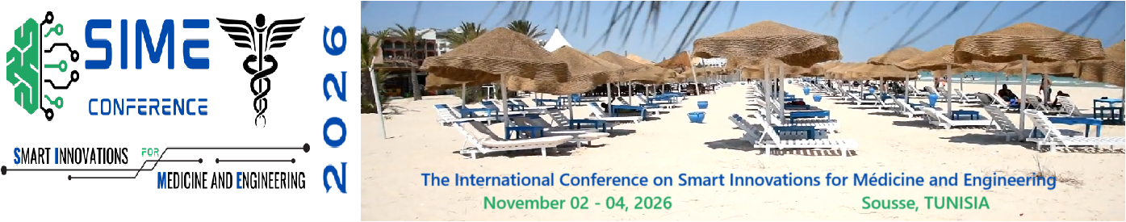

**CALL FOR PAPERS - SPECIAL SESSION**

**“Special Session Title”**

**for SIME 2026**

**November 02 -04, 2026 Sousse, Tunisia**

**1: Proposed Session Details**

* **1.1. Proposed Title of the Special Session:**
  + *[Provide a concise, specific, and engaging title that clearly reflects the session's theme, e.g., "AI-Powered Diagnostics: From Algorithms to Clinical Deployment"]*
* **1.2. Keywords:**
  + *[List 4-6 keywords that best describe the session's topic, e.g., Artificial Intelligence, Medical Imaging, Clinical Validation, Explainable AI, Diagnostic Software]*
* **1.3. Abstract/Rationale (Max 500 words):**
  + *[Provide a compelling description of the session. Explain the specific theme, its scientific and practical significance, and why it is timely and relevant to the International Conference SIME 2026 audience. Highlight the novelty of the topic and how it addresses current challenges or future directions in the field. Clearly state the objectives of the session and what you hope the audience will gain from it.]*
* **1.4. Session Format:**
  + *[Please select one:]*
    - [ ] **Traditional Presentation Session:** (90 mins, 4-5 presentations + Q&A)
    - [ ] **Panel Discussion:** (90 mins, moderated debate with 3-4 panelists and audience Q&A)
    - [ ] **Hybrid Format:** (e.g., 3 short presentations followed by a panel discussion). *Please describe: [ ]*

**2: Session Organizers (Chairs)**

* **2.1. Main Organizer / Primary Contact:**
  + **Full Name:**
  + **Affiliation:**
  + **Email:**
  + **Postal Address:**
  + **Short Biography (Max 150 words):** *[Include relevant expertise, research interests, and experience related to the session topic.]*
* **2.2. Co-Organizer(s) (if applicable):**
  + **Full Name:**
  + **Affiliation:**
  + **Email:**
  + **Short Biography (Max 150 words):**

**3: Proposed Speakers and Contributions**

*This section is crucial. While the final list of speakers may change, a strong proposal will have several confirmed or highly likely speakers.*

|  |  |  |  |  |
| --- | --- | --- | --- | --- |
|  | Speaker Full Name & Affiliation | Tentative Title of Presentation | Status (Confirmed / Invited / Targeted) | Email Contact |
| 1 |  |  | [ ] Confirmed [ ] Invited [ ] Targeted |  |
| 2 |  |  | [ ] Confirmed [ ] Invited [ ] Targeted |  |
| 3 |  |  | [ ] Confirmed [ ] Invited [ ] Targeted |  |
| 4 |  |  | [ ] Confirmed [ ] Invited [ ] Targeted |  |
| 5 |  |  | [ ] Confirmed [ ] Invited [ ] Targeted |  |
| 6 |  |  | [ ] Confirmed [ ] Invited [ ] Targeted |  |

**3.1. Confirmation Notes :**

* *[Please provide any additional details on the status of invitations. For confirmed speakers, it is recommended to include a brief email or letter of intent as an appendix.]*

**4: Plan for Session Management and Promotion**

* **4.1. Peer-Review Process:**
  + *[Describe how the submitted papers for your special session will be reviewed. Will you use the central conference system, or will you form your own mini-committee? How will you ensure a rigorous and fairpeer-review process?]*
* **4.2. Session Promotion Plan:**
  + *[Explain how you intend to promote this special session to attract high-quality submissions and a wide audience. (e.g., through professional networks, specific mailing lists, social media groups, related societies).]*

**5: Compliance and Agreement**

By submitting this proposal, the session organizers agree to:

1. Actively promote the Special Session Call for Papers.
2. Manage the review process for papers submitted to the session in a timely and professional manner, adhering to the conference deadlines.
3. Ensure all speakers in the session register for and attend the conference to present their work.
4. Chair the session during the conference.

**Name of Main Organizer :** __________________________________________

**Date:** _________________________

**Submission Checklist:**

Before submitting, please ensure your proposal includes:

* [ ] **Completed Sections 1-4.**
* [ ] **Short bios of all organizers.**
* [ ] **A tentative list of speakers and their contributions (Section 3).**
* [ ] **The signed agreement in Section 5.**
* [ ]** **Any letters of intent from confirmed speakers (as an appendix).**

**Submit your complete proposal via the submission Portal: [**[**Submit Now - SIME 2026**](https://sime-conf.org/submission-portal/)**]**  
**Deadline for Special Session Proposals: February 01, 2026**

**Contact:** For questions regarding Special Session proposals, please contact: us at [[sime.conf@gmail.com](mailto:sime.conf@gmail.com)].